**PROGRAM:**

**Exercise 6.html**

<!DOCTYPE html>

<html lang="en">

<head>

<meta charset="UTF-8">

<meta name="viewport" content="width=device-width, initial-scale=1.0">

<title>Customer CRUD App</title>

<link rel="stylesheet" href="ex_6_style.css">

</head>

<body>

<h2>Customer Management System</h2>

<form id="customerForm">

<input type="text" id="name" placeholder="Enter Name" required>

<input type="text" id="city" placeholder="Enter City" required>

<input type="text" id="mobile" placeholder="Enter Mobile No" required>

<button type="submit">Add Customer</button>

</form>

<table>

<thead>

<tr>

<th>Name</th>

<th>City</th>

<th>Mobile No</th>

<th>Actions</th>

</tr>

</thead>

<tbody id="customersList"></tbody>

</table>

<script>

const API_URL = 'http://localhost:5000/customers';

async function fetchCustomers() {

const res = await fetch(API_URL);

const customers = await res.json();

document.getElementById('customersList').innerHTML = customers.map(customer => `

<tr>

<td><input type="text" value="${customer.name}" id="name-${customer.id}"></td>

<td><input type="text" value="${customer.city}" id="city-${customer.id}"></td>

<td><input type="text" value="${customer.mobile}" id="mobile-${customer.id}"></td>

<td>

<button onclick="updateCustomer('${customer.id}')">Update</button>

<button onclick="deleteCustomer('${customer.id}')">Delete</button>

</td>

</tr>

`).join('');

}

async function addCustomer(event) {

event.preventDefault();

const name = document.getElementById('name').value;

const city = document.getElementById('city').value;

const mobile = document.getElementById('mobile').value;

await fetch(API_URL, {

method: 'POST',

headers: { 'Content-Type': 'application/json' },

body: JSON.stringify({ name, city, mobile })

});

document.getElementById('customerForm').reset();

fetchCustomers();

}

async function updateCustomer(id) {

const name = document.getElementById(`name-${id}`).value;

const city = document.getElementById(`city-${id}`).value;

const mobile = document.getElementById(`mobile-${id}`).value;

await fetch(`${API_URL}/${id}`, {

method: 'PUT',

headers: { 'Content-Type': 'application/json' },

body: JSON.stringify({ name, city, mobile })

});

fetchCustomers();

}

async function deleteCustomer(id) {

await fetch(`${API_URL}/${id}`, { method: 'DELETE' });

fetchCustomers();

}

document.getElementById('customerForm').addEventListener('submit', addCustomer);

fetchCustomers();

</script>

</body>

</html>

**Exercise 6 style.css**

body {

font-family: Arial, sans-serif;

text-align: center;

background-color: #f4f4f4;

}

form {

margin: 20px auto;

width: 50%;

padding: 15px;

background: white;

border-radius: 8px;

}

input {

padding: 10px;

margin: 5px;

width: 80%;

border: 1px solid #ccc;

}

table {

width: 60%;

margin: 20px auto;

border-collapse: collapse;

}

th, td {

padding: 10px;

border: 1px solid #ddd;

text-align: center;

}

button {

padding: 8px 12px;

border: none;

color: white;

border-radius: 5px;

}

button:nth-child(1) { background-color: #28a745; }

button:nth-child(2) { background-color: #dc3545; }

**Ex_6_server.js**

require('dotenv').config();

const express = require('express');

const mysql = require('mysql2');

const cors = require('cors');

const app = express();

app.use(express.json());

app.use(cors());

const db = mysql.createConnection({

host: process.env.DB_HOST,

user: process.env.DB_USER,

password: process.env.DB_PASS,

database: process.env.DB_NAME

});

db.connect(err => {

if (err) {

console.error("❌ MySQL Connection Error:", err.message);

process.exit(1);

}

console.log('✅ MySQL Connected');

});

app.post('/customers', (req, res) => {

const { name, city, mobile } = req.body;

const sql = 'INSERT INTO customers (name, city, mobile) VALUES (?, ?, ?)';

db.query(sql, [name, city, mobile], (err, result) => {

if (err) return res.status(500).json({ error: err.message });

res.json({ id: result.insertId, name, city, mobile });

});

});

app.get('/customers', (req, res) => {

const sql = 'SELECT * FROM customers';

db.query(sql, (err, results) => {

if (err) return res.status(500).json({ error: err.message });

res.json(results);

});

});

app.put('/customers/:id', (req, res) => {

const { name, city, mobile } = req.body;

const sql = 'UPDATE customers SET name = ?, city = ?, mobile = ? WHERE id = ?';

db.query(sql, [name, city, mobile, req.params.id], (err) => {

if (err) return res.status(500).json({ error: err.message });

res.json({ message: 'Customer updated successfully' });

});

});

app.delete('/customers/:id', (req, res) => {

const sql = 'DELETE FROM customers WHERE id = ?';

db.query(sql, [req.params.id], (err) => {

if (err) return res.status(500).json({ error: err.message });

res.json({ message: 'Customer deleted successfully' });

});

});

app.listen(5000, () => console.log('🚀 Server running on port 5000'));

**Output:**

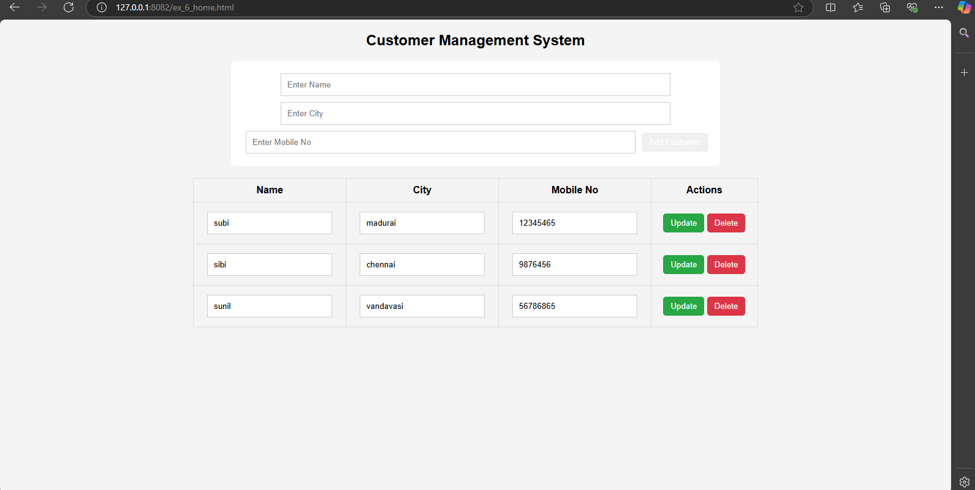

**PROGRAM:**

**Exercise 7.html**

<!DOCTYPE html>

<html lang="en">

<head>

<meta charset="utf-8" />

<link rel="icon" href="%PUBLIC_URL%/favicon.ico" />

<meta name="viewport" content="width=device-width, initial-scale=1" />

<meta name="theme-color" content="#000000" />

<meta

name="description"

content="Web site created using create-react-app"

/>

<link rel="apple-touch-icon" href="%PUBLIC_URL%/logo192.png" />

<link rel="manifest" href="%PUBLIC_URL%/manifest.json" />

<title>React App</title>

</head>

<body>

<noscript>You need to enable JavaScript to run this app.</noscript>

<div id="root"></div>

</body>

</html>

**App.css**

.App {

text-align: center;

}

.App-logo {

height: 40vmin;

pointer-events: none;

}

@media (prefers-reduced-motion: no-preference) {

.App-logo {

animation: App-logo-spin infinite 20s linear;

}

}

.App-header {

background-color: #282c34;

min-height: 100vh;

display: flex;

flex-direction: column;

align-items: center;

justify-content: center;

font-size: calc(10px + 2vmin);

color: white;

}

.App-link {

color: #61dafb;

}

@keyframes App-logo-spin {

from {

transform: rotate(0deg);

}

to {

transform: rotate(360deg);

}

}

**App.js**

import React, { useState } from 'react'; // Import useState from React

import logo from './logo.svg';

import './App.css';

function App() {

const [count, setCount] = useState(0);

const handleClick = () => {

setCount(count + 1); // Increase the count by 1 each time the button is clicked

};

return (

<div className="App">

<header className="App-header">

<img src={logo} className="App-logo" alt="logo" />

<p>

Edit <code>src/App.js</code> and save to reload.

</p>

<a

className="App-link"

href="https://reactjs.org"

target="_blank"

rel="noopener noreferrer"

>

Learn React

</a>

{/* Button to trigger count update */}

<button onClick={handleClick}>Click Me!</button>

{/* Display the click count */}

<p>Click count: {count}</p>

</header>

</div>

);

}

export default App;

**Output:**

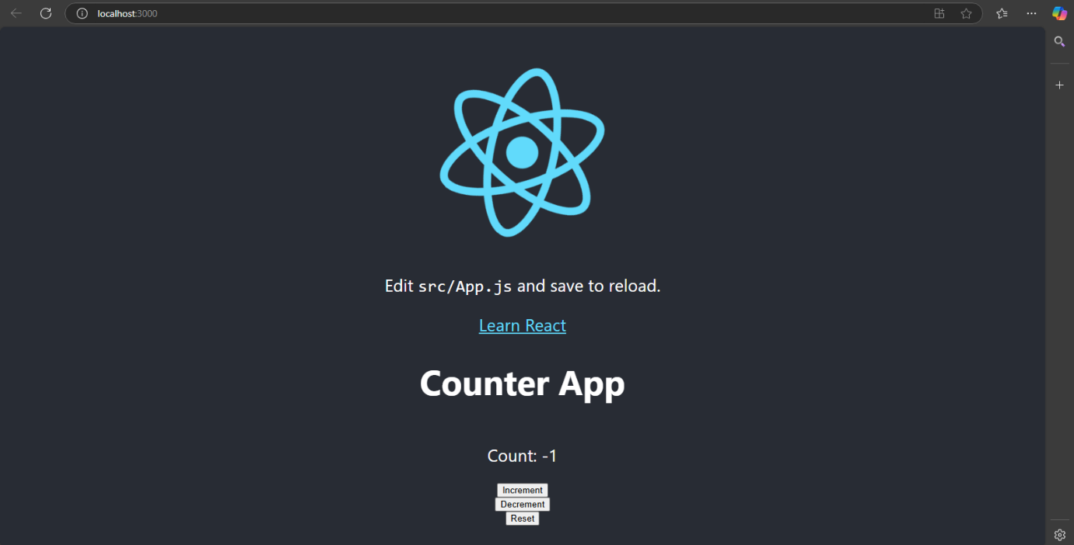

**PROGRAM:**

**Exercise 8:**

**App.js**

import React, { useState } from 'react';

import './App.css';

function App() {

const [todos, setTodos] = useState([]);

const [input, setInput] = useState('');

const [editIndex, setEditIndex] = useState(null);

const [editText, setEditText] = useState('');

const handleInputChange = (e) => {

setInput(e.target.value);

};

const addTodo = () => {

if (input.trim() !== '') {

setTodos([...todos, { text: input, completed: false }]);

setInput('');

}

};

const toggleComplete = (index) => {

const updatedTodos = todos.map((todo, i) =>

i === index ? { ...todo, completed: !todo.completed } : todo

);

setTodos(updatedTodos);

};

const deleteTodo = (index) => {

const updatedTodos = todos.filter((_, i) => i !== index);

setTodos(updatedTodos);

};

const editTodo = (index) => {

setEditIndex(index);

setEditText(todos[index].text);

};

const saveEdit = () => {

if (editText.trim() !== '') {

const updatedTodos = todos.map((todo, i) =>

i === editIndex ? { ...todo, text: editText } : todo

);

setTodos(updatedTodos);

setEditIndex(null);

setEditText('');

}

};

return (

<div className="App">

<h1>To-Do App</h1>

<div className="todo-input">

<input

type="text"

value={input}

onChange={handleInputChange}

placeholder="Enter a new task"

/>

<button className="add-btn" onClick={addTodo}>Add</button>

</div>

{/* Edit todo */}

{editIndex !== null && (

<div className="edit-todo">

<input

type="text"

value={editText}

onChange={(e) => setEditText(e.target.value)}

placeholder="Edit your task"

/>

<button className="save-btn" onClick={saveEdit}>Save</button>

</div>

)}

<table className="todo-table">

<thead>

<tr>

<th>Task</th>

<th>Actions</th>

</tr>

</thead>

<tbody>

{todos.map((todo, index) => (

<tr key={index}>

<td className={todo.completed ? 'completed' : ''}>

<span onClick={() => toggleComplete(index)}>{todo.text}</span>

</td>

<td>

<button className="edit-btn" onClick={() => editTodo(index)}>Edit</button>

<button className="delete-btn" onClick={() => deleteTodo(index)}>Delete</button>

</td>

</tr>

))}

</tbody>

</table>

</div>

);

}

export default App;

**App.css**

.App {

text-align: center;

margin-top: 20px;

font-family: Arial, sans-serif;

}

.todo-input {

margin-bottom: 20px;

}

input {

padding: 10px;

font-size: 16px;

width: 250px;

}

button {

padding: 10px;

font-size: 16px;

cursor: pointer;

margin-left: 10px;

border: none;

border-radius: 4px;

}

.add-btn {

background-color: green;

color: white;

}

.add-btn:hover {

background-color: darkgreen;

}

.delete-btn {

background-color: red;

color: white;

}

.delete-btn:hover {

background-color: darkred;

}

.edit-btn {

background-color: orange;

color: white;

}

.edit-btn:hover {

background-color: darkorange;

}

.todo-table {

width: 80%;

margin: 0 auto;

border-collapse: collapse;

}

th, td {

padding: 10px;

text-align: left;

border: 1px solid #ddd;

}

th {

background-color: #f2f2f2;

}

.completed {

text-decoration: line-through;

color: gray;

}

.edit-todo {

margin-top: 20px;

}

.edit-todo input {

padding: 10px;

font-size: 16px;

width: 250px;

}

.save-btn {

background-color: blue;

color: white;

cursor: pointer;

padding: 10px;

margin-left: 10px;

}

.save-btn:hover {

background-color: darkblue;

}

**Output:**

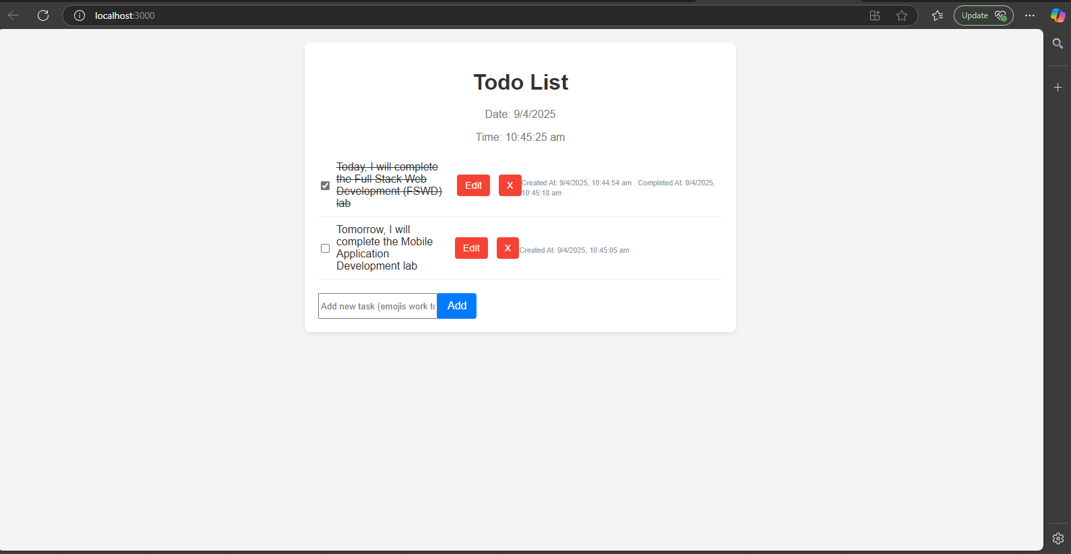

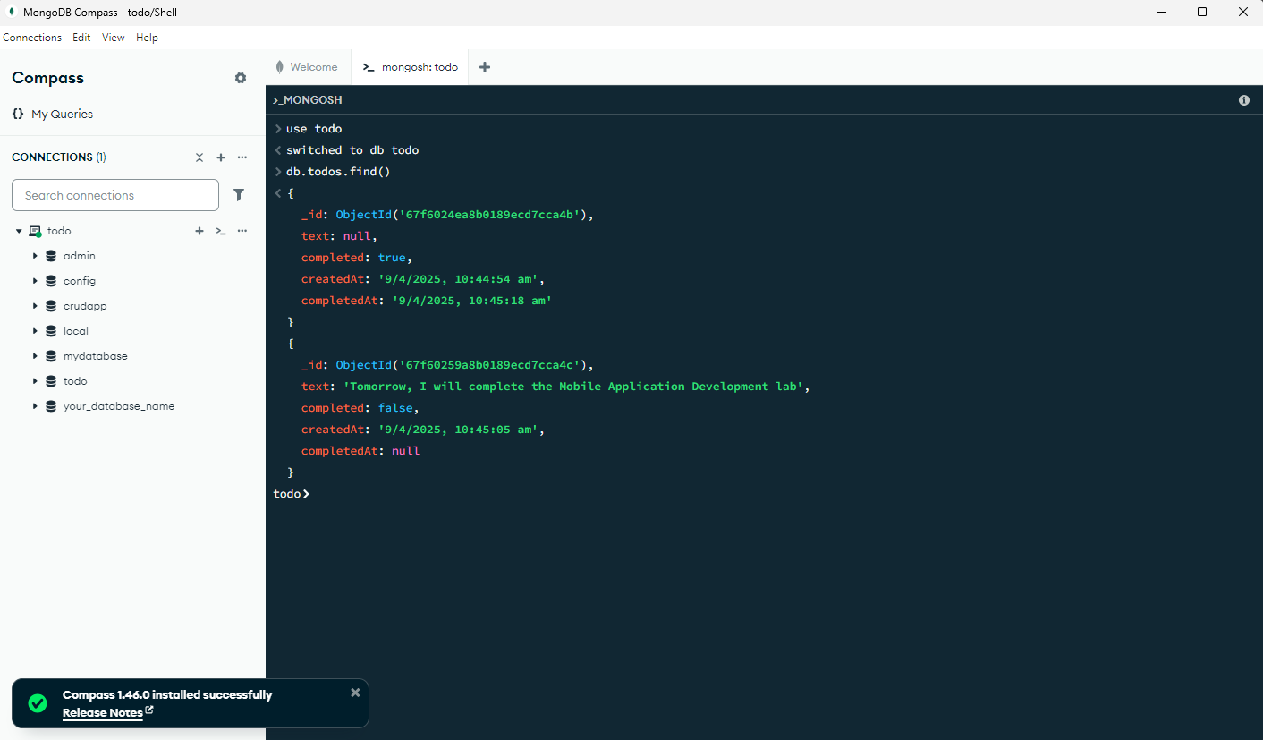

**PROGRAM**

**Exercise 9**

**models/user.js**

const mongoose = require('mongoose');

const UserSchema = new mongoose.Schema({

    username: { type: String, required: true, unique: true },

    password: { type: String, required: true }

});

module.exports = mongoose.model('User', UserSchema);

**routes/user.js**

import express from 'express';

import { getAllUsers, login, logout, signUp } from "../controllers/user.js";

import { checkRole, checkToken } from '../middlewares/middlewares.js';

const router = express.Router();

router.post("/signUp", signUp);

router.post("/login", login);

router.post("/logout", checkToken, logout);

router.get('/getAllUsers', checkToken, checkRole(['admin', 'manager']), getAllUsers);

export default router;

**Server.js**

const express = require('express');

const connectDB = require('./config/db');

const cookieParser = require('cookie-parser');

const authRoutes = require('./routes/auth');

require('dotenv').config();

const app = express();

const PORT = process.env.PORT || 2222;

app.use(express.json());

app.use(cookieParser());

app.use('/api/auth', authRoutes);

connectDB();

app.listen(PORT, () => console.log(`Server running on port ${PORT}`));

**controller/user.js**

import bcrypt from 'bcrypt';

import User from "../models/user.js";

import { CreateToken } from '../middlewares/middlewares.js';

import jsonwebtoken from 'jsonwebtoken';

export const signUp = async (req, res) => {

  const { name, mobile, email, password, role } = req.body;

  if (!name || !mobile || !email || !password) {

    return res.status(422).json({ message: "All feilds should be filled" })

  }

  try {

    let existingUser;

    try {

      existingUser = await User.findOne({ $or: [{ email: email }, { mobile: mobile }] });

    } catch (err) {

      console.error(err);

    }

    if (existingUser) {

      if (existingUser.email == email) {

        return res.status(409).json({ message: "A User is already signUp with this email" })

      }

      else if (existingUser.mobile == mobile) {

        return res.status(409).json({ message: "A User is already signUp with this mobile" })

      }

    }

    const salt = await bcrypt.genSalt(6)

    const hashedpassword = await bcrypt.hash(password, salt);

    const user = new User({

      name,

      mobile,

      email,

      password: hashedpassword,

      role: role,

    });

    await user.save();

    return res.status(201).json({ message: "Account Creation is success, Login to your account", User: user })

  } catch (err) {

    console.error(err)

    return res.status(400).json({ message: "Error in saving user in DB" });

  }

}

export const login = async (req, res) => {

  const { email, password } = req.body;

  if (!email || !password) {

    return res.status(422).json({ message: "All feilds should be filled" })

  }

  let loggedUser;

  try {

    loggedUser = await User.findOne({ email: email });

    if (!loggedUser) {

      return res.status(404).json({ message: "Email is not found, Check it and try again" })

    }

    const isPasswordCorrect = bcrypt.compareSync(password, loggedUser.password);

    if (!isPasswordCorrect) {

      return res.status(400).json({ message: "Invalid password, Check it and try again" })

    }

    const token = CreateToken(loggedUser._id);

    res.cookie(String(loggedUser._id), token, {

      path: "/",

      expires: new Date(Date.now() + 1000 * 59),

      httpOnly: true      sameSite: "lax"

    })

    return res.status(200).json({ message: "Successfully logged in", User: loggedUser })

  } catch (err) {

    console.log(err)

  }

}

export const logout = (req, res) => {

  const cookies = req.headers.cookie

  const previousToken = cookies.split("=")[1];

   if (!previousToken) {

    return res.status(400).json({ message: "Couldn't find token" });

  }

  jsonwebtoken.verify(String(previousToken), process.env.JWTAUTHSECRET, (err, user) => {

    if (err) {

      console.log(err);

      return res.status(403).json({ message: "Authentication failed" });    }

    res.clearCookie(`${user.id}`);

    req.cookies[`${user.id}`] = "";

    return res.status(200).json({ message: "Successfully Logged Out" });

  });

};

export const getAllUsers = async (req, res) => {

  try {

    const allusers = await User.find();

    if (!allusers) {

      return res.status(404).json({ message: "There are not any users" });

    }

    else {

      res.status(200).json({ allusers })

    }

  } catch (error) {

    console.log(error);

    return res.status(500).json({ message: "Error in getting the Users" })

  }

}

**Output**

